**Linux Practical**

**Date: 30 September**

COMMANDS

**1)Create a file:**

**$cat >catty.txt**

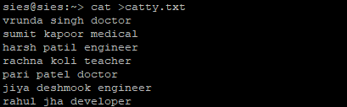

**2) awk command:**

**$awk ‘{print}’ catty.txt:** It will displays the whole

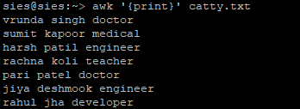

**$awk ‘/engineer/{print}’ catty.txt:**It will shows the engineer names



**$awk ‘{print $1,$3}’ catty.txt:** It will print first and third lines in our files

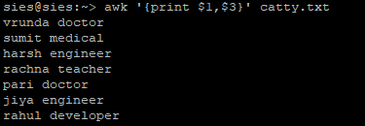

**$awk ‘NR{print NR}’ catty.txt:** It shows how many lines are there

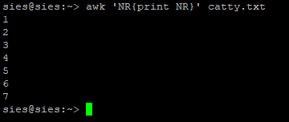

**[ i) PID**: Unique process ID

**ii) TTY**: Terminal Type

**iii) TIME**: Amount of CPU in minutes & seconds that process run in

**iv) CMD**: Nano of command that launch the process **]**

**3) ps command**: called a process status

**i) ps –l:** It is used to display information related to the process

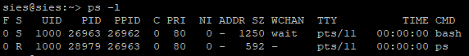

**ii) ps –A**: It will shows all the process

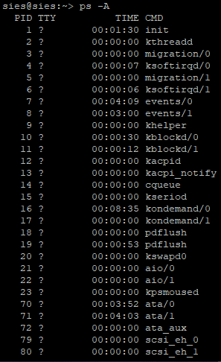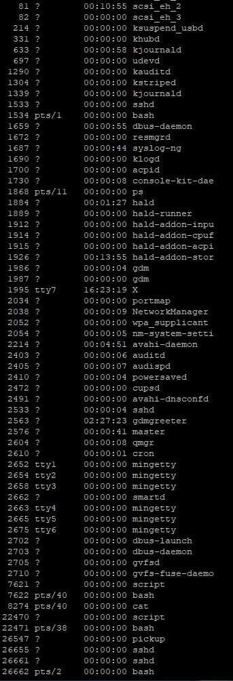

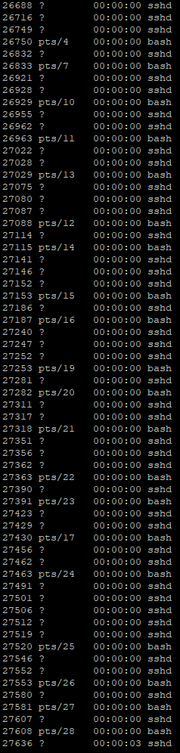 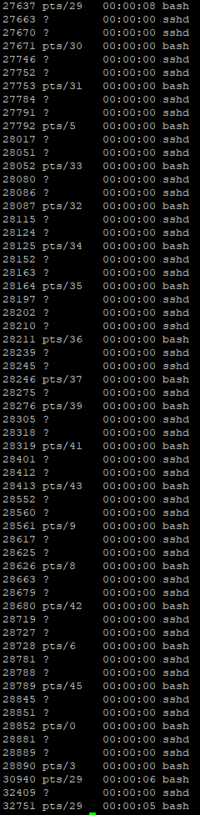

**4)kill command** :This command terminates the process ,Displays available signal you can use

**sh command:** sh is a shell command-line interpreter of Unix/Unix-like operating systems  sh provides some built-in commands. bash is a superset of sh. Shell is a command-line interface to run commands and shell scripts.

**nice command:** nice command in Linux helps in execution of a program/process with modified scheduling priority

**batch command:** Batch files are files processed in batches, allowing Windows users to automate system and program processes. To this end, these files receive commands, also called batch commands, which are run through thecommandline or by prompt.

**at command:** at command is a command-line utility that is used to schedule a command to be executed at a particular time in the future